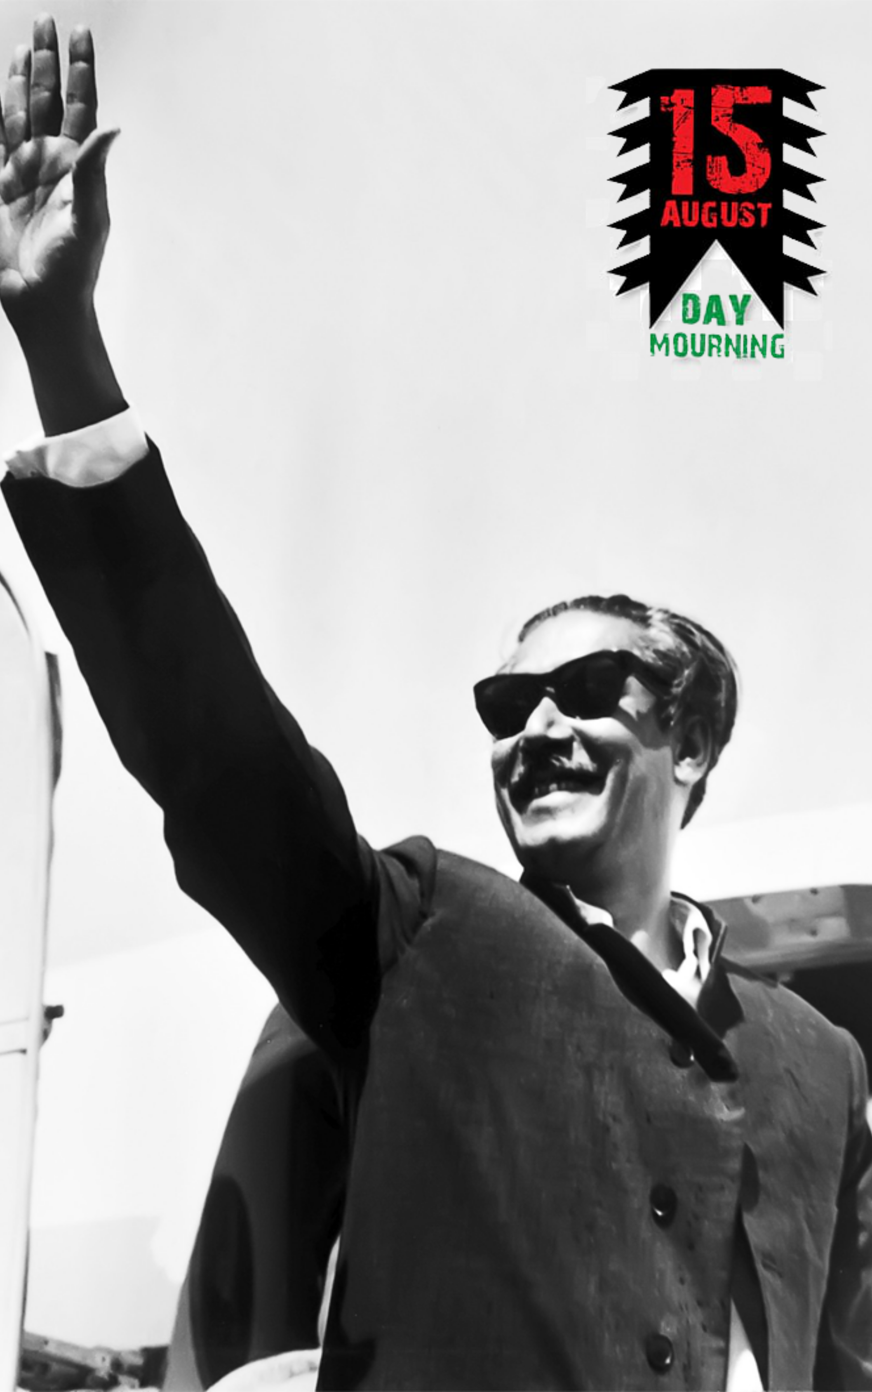



**American International University-Bangladesh (AIUB)**

**Assignment Topic**

**National Mourning Day**

**Submitted by**

**Name: Nokibul Arfin Siam.**

**Institute ID: 21-44793-1.**

**Submitted to**

**Name: Ashika Bari Jotee.**

**Faculty, English.**

|  |  |
| --- | --- |
| **Partner Name** | **ID** |
| Imran Hossain | 21-44800-1 |
| MD. Siam Mostofa | 21-44829-1 |

***National Mourning Day***

National Mourning Day is a public holiday in Bangladesh on August 15th. It commemorates the murder of Bangabandhu Sheikh Mujibur Rahman, known as the 'Father of the Nation' on this day in 1975. It is not an easy task to invigored and lead the right leadership by organizing a divided subjugated nation. But Bangabandhu was able to do this difficult task very easily. Sheikh Mujibur Rahman has handled the struggle for freedom from swadhika with immense skill and ability. He had a wonderful thunderbolt to inspire people. He had a huge reputation as an illuminate speaker. But did the killers not brutally kill this leader, the best of all and the beloved of Bengali! At the same time, the assassins not only killed one person but also killed the bloody sun of freedom by killing 160 million Bengali fathers, killing the true symbol of the aspirations of all the innocent, oppressed, exploited, oppressed people of the society. The assassins wrote the darkest chapter in the history of the Bengali nation and Bangladesh on August 15, 1975, by killing Bangabandhu Sheikh Mujibur Rahman, the painter of the thousand-year-old Bengali independent Bangladesh state. August 15 is a tainted day in the life of the nation.

Bangabandhu Sheikh Mujibur Rahman is one of the few people who has made history in the lives of the Bengali nation. One day the entire Bengali nation woke up to his generous call. He became a symbol of liberation in Bangladesh, stained with the blood of three million Bengalis, a source of inspiration. Very few political leaders in the world were able to gain such enviable popularity like him. He made the dream of freedom far away from the scheme a reality. But that is him. Did some army endangered military officers not brutally kill? That is why this day is seen as the most tainted day in the history of Bangladesh. Bengali may never be able to compensate for the irreparable damage caused by the killers that day by killing the metaphor of independent Bangladesh. Bangabandhu was a Zen man who, as a leader, was the ideal of a political worker, the refuge and trust of a nation as a father, as difficult as a hill, as hard as a hill, as strong as truth and Kusum, a symbol of the trust of a needy miserable man. That's why everyone, including the killers, knew that there was no impossible thing this man couldn't do in Bengal. Therefore, it is very important to eradicate this man to stop the progress of the newly liberated independent land of Bangladesh or to stop the victory of Bangladesh.

Sheikh Mujib died after being hit by a killer bullet but the end of Sheikh Mujib is never possible from this Bengali. He will live through his work for life in the heart of all Bengalis. The ungrateful Bengali will remember their beloved leader with reverence for his gratitude throughout his life. That is why August 15 is the most sad, tainted and mourning day of Bengali life. On this day, Bengali remembered the father of the nation Bangabandhu Sheikh Mujibur Rahman with a burden of sorrow. The rule of Sheikh Mujibur Rahman was in force in Bangladesh from January 11, 1972 to August 15, 1975. At that time, in just 3 years and 8 months, sheikh mujib's single and all-round led Awami League party government, which led the war of independence, collapsed and the leadership came to an end. Below are some of the reasons responsible for this.

1. **Disregard of Army**: Since assuming power to run the state, the Awami League government has not given that importance to the development and modernization of the Bangladesh Army. The hostile attitude towards military officers back to Pakistan and the rapid promotion of Awami League-backed officers, the steadily reducing the amount of defense spending and the rapid development and rapid development of the military forces parallel to the military arm and the government's dependence on it caused a lot of anger among the military personnel for very natural reasons. Therefore, in the wake of the unlimited greed and disinterest of the party men of the Tasin government, some of the army's endangered officers killed Sheikh Mujibur Rahman with his family on the night of August 15, 1975, in order to reduce the popularity of the Mujib government.
2. **Political Reason**: In 1975, by organizing the Fourth Amendment to the Constitution, the Awami League government banned all political activities and political parties in the country and axed the core of democracy by introducing a one-party regime. This led to resentment in the minds of the public. In addition, after the Fourth Amendment to the Constitution, the Awami League government was cut off from the public because of the closure of all newspapers except 4, the reduction of judiciary power and, above all, various methods of undermining the fundamental rights of the people.
3. **Military Coup**: They were dissatisfied with the government's unexpected treatment of some army officers.

Moreover, due to various other reasons, there was discontent in the minds of the people at that time. On this occasion, some dishonest army officers and freedom fighters plotted to assassinate Bangabandhu and killed him and his family.

In the early morning hours of August 15, Bangabandhu, the father of the Bengali nation, the architect of the thousand-year-old Bengali Bangladesh, was killed in the early hours of the morning by ambitious treacherous officers at his residence. On that day, Bangabandhu's consort, Mahiyasi Woman Begum Fazilatunnecha, Bangabandhu’s eldest son, Freedom Fighter Le. Sheikh Kamal, son Lt. Sheikh Jamal, youngest son Sheikh Russell, two daughters-in-law Sul Kamal and Rosie Kamal, Bangabandhu's brother Sheikh Nasser, 16 people including sister and agriculture minister Abdur Rob Serniabat and his daughter Baby Serniabat, son Arif Serniabat, dohitra Sukantabdullah Babu, nephew Shadi Serniabat, Bangabandhu's nephew youth leader and journalist Sheikh Fazlul Haque Mani and his pregnant wife Arju Mani, Bangabandhu military secretary Colonel Jamil Ahmed and 14-year-old Abdul Naeem Khan Rintu were killed by the killers. At that time, the two daughters of Bangabandhu Sheikh Mujibur Rahman, the present Prime Ministers, Hon'ble Sheikh Hasina and Sheikh Rehena, survived as they were out of the country.

On that day, some young unscrupulous army officers participated in the heinous murder. Twelve of these accused were sentenced to death. These are Army Officers Syed Farooq Rahman, Sultan Shahriar Rashid Khan, Khandkar Abdur Rashid, Bazlul Huda, Shariful Haque Pomegranate, A.M. Rasheed Chowdhury, AKM Mohiuddin Ahmed (Lancer), M.H.M.B. Noor Chowdhury, Aziz Pasha (dead), Muhiuddin Ahmed (Artillery), Risaldar Moslem Uddin and Abdul Majed. Five of them have been sentenced to death.

In conclude, On August 15, 1975, it was Bengali a dark chapter in the life of the nation. So, the nation celebrates this day through mourning. Because if the father of the nation is to be brutally murdered like this, then there is no greater moment of pain for that nation. So, this day is remembered with great pain by 160 million people of this country. And it is called the National Mourning Day of Bangladesh.

1177 Words